Colin van Dongen MG1A

DIP – Objects, Functions & Attributes

|  |  |  |
| --- | --- | --- |
|  | attributes | functions |
| 1 player/hero (Ryu) | Speed  Sprite | Jump  Walk |
| 2 energy pulse | Speed  Sprite | Movement  damage |
| 3 enemy (Ken) | Speed  Sprite | Jump  Walk |

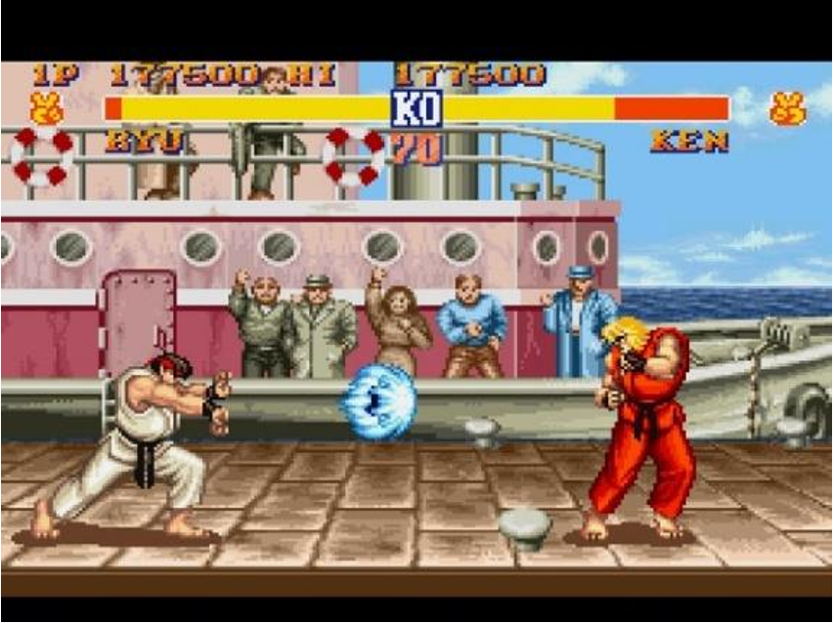

1 2 3

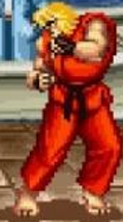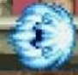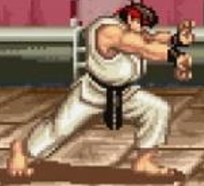

|  |  |  |
| --- | --- | --- |
|  | attributes | functions |
| 1 enemy | Speed  Sprite | Movement  Attack |
| 2 hero (shovel knight) | Sprite  Speed | Attack  Jump |
| 3 info bar | Icons  text | Showing how much health  Increasing numbers |

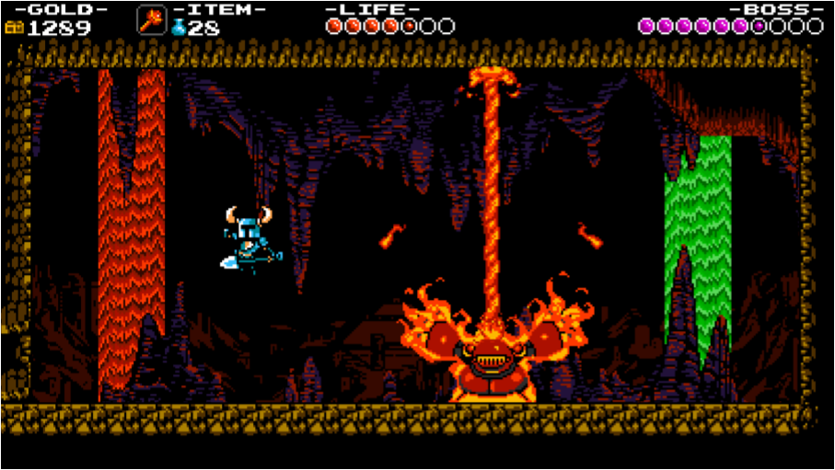

1 2 3

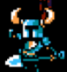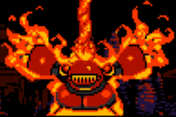



|  |  |  |
| --- | --- | --- |
|  | attributes | functions |
| 1 hero | Speed  sprite | Movement  Getting XP |
| 2 enemy | Speed  health | Movement  Using abilities |
| 3 minion | Speed  health | Movement  attack |

1 2 3

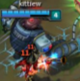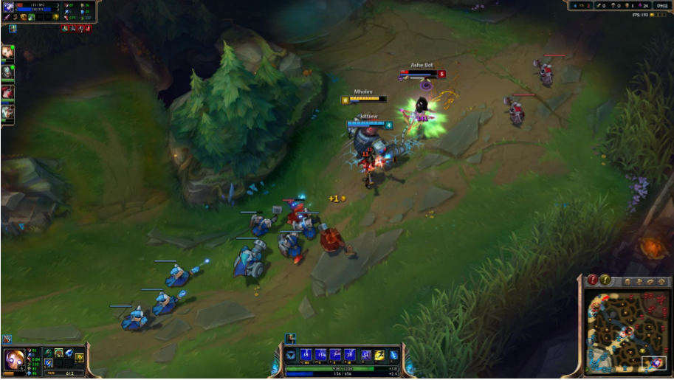

|  |  |  |
| --- | --- | --- |
|  | attributes | functions |
| 1 character 1 | Sprite  speed | Movement  attack |
| 2 creature | Health  sprite | Attack  movement |
| 3 command window | Text  sprite | Selecting move  Showing what move |



1 2 3

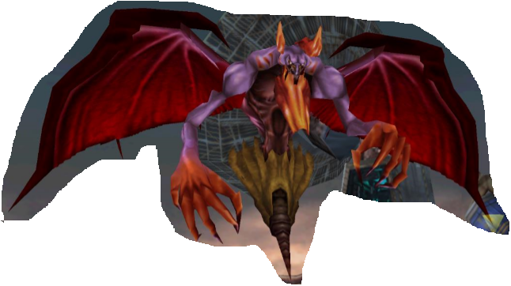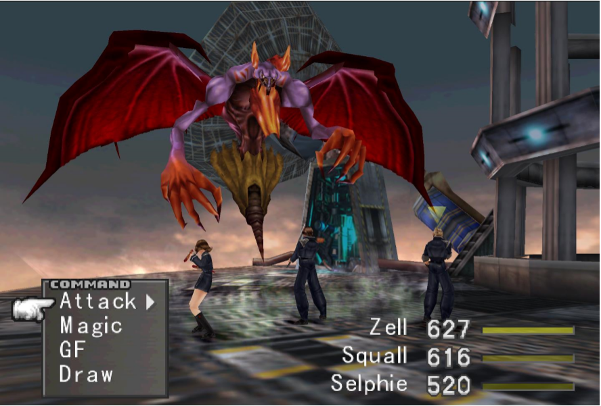

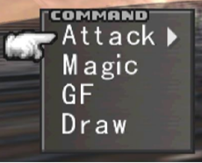

|  |  |  |
| --- | --- | --- |
|  | attributes | functions |
| 1 enemy | Sprite  speed | Die  walk |
| 2 gun | Sprite  speed | Shooting  Rotating view |
| 3 stats bar | Text  sprite | Showing health  Showing ammo |

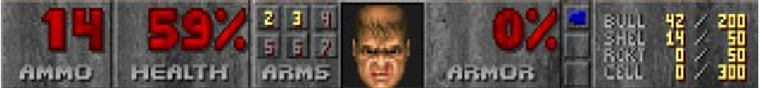

1 2 3

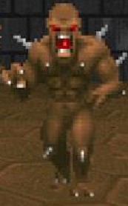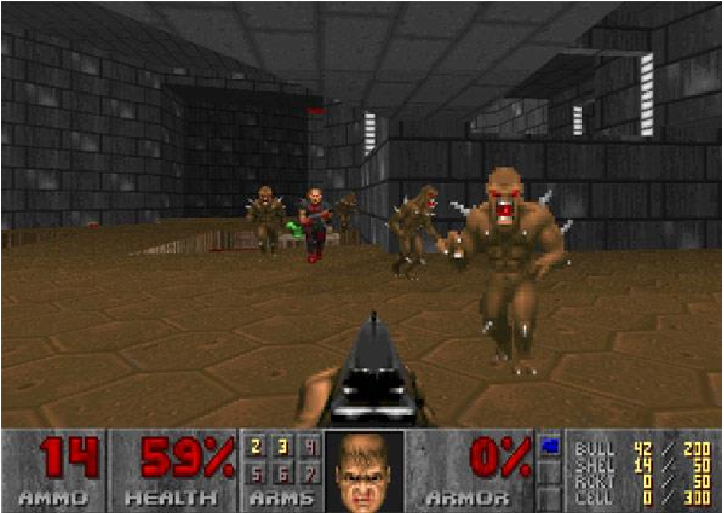

|  |  |  |
| --- | --- | --- |
|  | attributes | functions |
| 1 progress bar | Sprite  points | Showing the progress  Filling the bar |
| 2 sealed candy | Sprite  points | Stuck  unlocking |
| 3 colorfull candy | Sprite  power | Explode  Switch places |



1 2 3

